**Name: Muhammad Huzaifa**

**Roll no: SU92-BSAIM-S24-010**

**Section: 3A**

**Subject: AI LAB**

**Documentations:**

**Mini Project 1: Fizz Buzz**

**Code Explanation:**

* The function fizz_Buzz(n) runs a loop from 1 to n.
* If a number is divisible by **both 3 and 5**, it prints "Fizz Buzz".
* If a number is only divisible by **3**, it prints "Fizz".
* However, there is a **logical error** in the condition:

**if i % 3 and i % 5 == 0**

1. This does not check divisibility correctly. Instead, it should be:

**if i % 3 == 0 and i % 5 == 0**

1. The current condition will not print "Fizz Buzz" correctly.

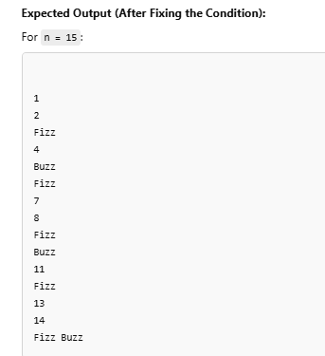

**Mini Project 2: Movie Budget Analysis**

**Code Explanation:**

1. **cal_ave_budget(movies):**
   * This function calculates the **average budget** of all movies.
   * It sums up all movie budgets and divides by the total number of movies.
   * If no movies exist, it prints a message and returns 0.
2. **high_budget_movies(movies, ave_budget):**
   * This function prints movies with a budget **higher than the average**.
   * It also displays how much each movie **exceeds the average budget**.
   * The total number of such movies is also counted and displayed.
3. **add_movies(movies):**
   * Allows the user to **add new movies** with their budget.
   * The inputted movie details are appended to the movies list.
4. **movie_budget_analysis():**
   * A predefined list of **Pakistani movies** with their budgets is given.
   * It calls add_movies() to allow users to enter additional movies.
   * Calculates **average budget** using cal_ave_budget().
   * Finds and prints movies with **higher budgets than the average**.
   * 